
NATIONAL INSTITUTE OF TECHNOLOGY PUDUCHERRY
(An Institution of National Importance under MHRD, Govt. of India)
KARAIKAL – 609 609

DEPARTMENT OF COMPUTER SCIENCE AND ENGINEERING
Roll Number: | CS19B1016 | Name | BOYINA AJAY SANTHOSH
Semester: | II | Class: | B TECH 1ST YEAR
Subject Code: | CS106 | Subject Name: | DATA STRUCTURES LABORATORY

7.1 TRAVERSALS OF TREE
Date:20.2.20

AIM:

To implement preorder , postorder , inorder traversals of a binary tree.

ALGORITHM:
1. start the program.
2. declare array of left child and right child.
3. through recursive functions create the tree using lc and rc.
4. now apply these traversals through recursive functions.
5. in preorder, first element is the root
6. in postorder, last element is the root.
7. by using inorder we can determine left and right subtree of any element.
8. display these traversals.
9. close this program.

PROGRAM:
#include<stdio.h>
#include<stdlib.h>
struct node
{
int data;
struct node *left,*right;
};
typedef struct node nd;
nd *buildtree(int);
nd *inorder(nd *);
nd *preorder(nd *);
nd *postorder(nd *);
int arr[100];
int lc[7]={1,3,5,-1,-1,-1,-1};
int rc[7]={2,4,6,-1,-1,-1,-1};
int main()
{
nd *root;
int k;
root=buildtree(0);
printf("preorder traversal:\n");
root=preorder(root);
printf("\n");
printf("inorder traversal:\n");
root=inorder(root);
printf("\n");
printf("postorder traversal:\n");
root=postorder(root);
k=height(root);
printf("\n height of the tree is %d\n",k);
}
nd *buildtree(int index)
{
nd *temp=NULL;
if(index!=-1)
{
temp=(nd *)malloc(sizeof(nd));
temp->left=buildtree(lc[index]);
printf("enter data for node no. %d\n",index);
scanf("%d",&arr[index]);
temp->data=arr[index];
temp->right=buildtree(rc[index]);
}
return temp;
}
nd *preorder(nd *root)
{
if(root!=NULL)
{

printf("%d\t",root->data);
preorder(root->left);
preorder(root->right);
}
return root;
}
nd *postorder(nd *root)
{
if(root!=NULL)
{
postorder(root->left);
postorder(root->right);
printf("%d\t",root->data);
}
return root;
}
nd *inorder(nd *root)
{
if(root!=NULL)
{
inorder(root->left);
printf("%d\t",root->data);
inorder(root->right);
}
return root;
}
int height(nd *root)
{
int lh=0,rh=0;
if(root==NULL)
{
return 0;
}
else
{
lh=height(root->left);
rh=height(root->right);
if(lh>=rh)
{
return (lh+1);
}
else
{
return (rh+1);
}
}
}

OUTPUT:

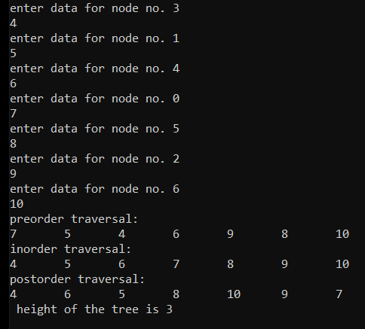

RESULT:

The program is successfully executed.

7.2 BINARY SEARCH TREE PROGRAM

AIM:
To construct binary search tree and to search element in this tree.

ALGORITHM:
1. Start the program.
2. first apply insertion.
3.declare root=null.
4. if root=null then create a node and we have to insert data in created node.
5. if root->data is greater than our given data then go insert(root->left).
6. else go insert(root->right)
7. return root
8.So in this way we can construct bst through recursive functions.
9. in best case its time complexity is logn and in worst case the time complexity is order of n.
10. we can search our required element by using this procedure.
11. we can delete any node ( having one or no children) in this method
(first we have to find that node and delete that node and return null)
12. in the case of node having two children
( first we have to find this node and we have to find the inorder successor of this node and change the data of our node to data of inorder successor of this node and delete the inorder successor node by using recursive functions)
13. finally return root and close the program.

PROGRAM:
#include<stdio.h>
#include<stdlib.h>
#include<conio.h>
int i=0;
struct node
{
int data;
struct node *left;
struct node *right;
};
typedef struct node nd;
nd *getnewnode(int data)
{
nd *newnode;
newnode=(nd *)malloc(sizeof(nd));
newnode->data=data;
newnode->left=NULL;
newnode->right=NULL;
return newnode;
}
nd *insertion(nd *root,int data)
{
if(root==NULL)
{
root=getnewnode(data);
}
else if(data<=root->data)
{
root->left=insertion(root->left,data);
}
else if(data>=root->data)
{
root->right=insertion(root->right,data);
}
return root;
}
void print(nd *root)
{
if(root!=NULL)
{
printf("%d\t",root->data);
print(root->left);
print(root->right);
}
}
int search(nd *root,int k)
{
if(root==NULL)
{
return 0;
}
else if(k<root->data)
{
i=2i+1;
return search(root->left,k);
}
else if(k>root->data)
{
i=2i+2;
return search(root->right,k);
}
else if(k==root->data)
{
return 1;
}
}
nd *min(nd *root)
{
nd *node;
node=root;
while(node->left!=NULL)
{
node=node->left;
}
return node;
}
nd *deletebst(nd *root,int data)
{
if(root==NULL)
{
return root;
}
else if(root->data>data)
{
root->left=deletebst(root->left,data);
}
else if(root->data<data)
{
root->right=deletebst(root->right,data);
}
else
{
nd *temp;
if(root->right==NULL && root->left==NULL)
{
free(root);
return NULL;
}
else if(root->right==NULL)
{
temp=root;
root=root->left;
free(temp);
return root;
}
else if(root->left==NULL)
{
temp=root;
root=root->right;
free(temp);
return root;
}
else
{
temp=min(root->right);
root->data=temp->data;
root->right=deletebst(root->right,temp->data);
return root;
}
}
}

int main()
{
int i,n,k,l;
int data;
nd *root;
root=NULL;
printf("enter no. of elements\n");
scanf("%d",&n);
for(i=0;i<n;i++)
{
printf("enter data: \n");
scanf("%d",&data);
root=insertion(root,data);
}
print(root);
printf("\n");
printf("enter element u want to search\n");
scanf("%d",&k);
l=search(root,k);
if(l==1)
printf("element is found in node no. %d\n",i);
else
printf("element not found\n");
printf("enter data to delete\n");
scanf("%d",&data);
deletebst(root,data);
print(root);
}

OUTPUT:

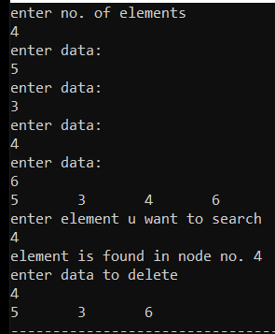

RESULT:

The program is successfully executed.

